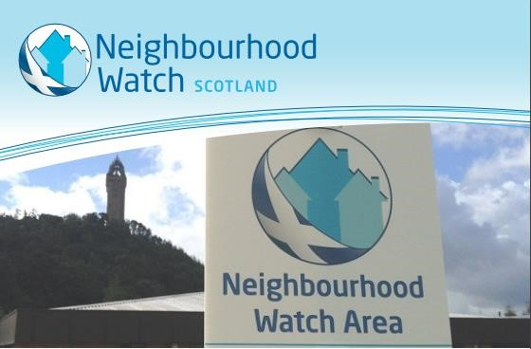What is Neighbourhood Watch?

**Our Vision:**

Our vision is a society that is empowered through proactive local cooperation and community spirit to create safe, strong and resilient neighbourhoods, to the benefit of all.

**Our mission:**

To achieve this our primary focus will be to support and enable individuals to become connected and actively engaged, with the intention to lessen crime and improve quality of life.

Neighbourhood Watch Scotland SCIO, Charity Number SC036510

Registered Office: 21 Claylands Road Newbridge, Edinburgh, EH28 8LF

Phone Number : 01786 463732

Website : **www.neighbourhoodwatchscotland.co.uk**

What do Neighbourhood Watches do?

There is no simple answer to this question, as each group is individual to its area and to the community it serves. Depending on local issues and priorities, Neighbourhood Watch groups decide how best to keep their communities safe.

In general terms, people in Neighbourhood Watch:

* Care about and have pride in their neighbourhood
* Are aware of how to stay safe and prevent crime
* Know who to contact for assistance or advice on safety issues
* Where possible, assist people who are less able to look after themselves
* Help raise awareness of safety issues and Alerts locally
* Report information to relevant agencies (e.g. Police, Local Authority etc)
* Are welcoming and inclusive of all members of the neighbourhood

Why should I get involved in Neighbourhood Watch?

Getting involved in Neighbourhood Watch can bring a number of benefits to your local community.

In general terms, people in Neighbourhood Watch:

* Brings people together and helps develop community spirit
* A visible sign that residents care about the area and the people who

live in it

* Can help prevent crime
* Helps the police and other agencies detect crime through clear communication and swift reporting
* People know how to keep themselves and others safe
* Helps reassure people and reduce fear of crime

Neighbourhood Watch Scotland SCIO, Charity Number SC036510

Registered Office: 21 Claylands Road Newbridge, Edinburgh, EH28 8LF

Phone Number : 01786 463732

Website : **www.neighbourhoodwatchscotland.co.uk**

How do I get involved in Neighbourhood Watch?

Its never been easier to get involved. You can do everything online, or just give us a call and we will help you out!

Is there a Neighbourhood Watch near me?

Visit our website to find out [www.neighbourhoodwatchscotland.co.uk](http://www.neighbourhoodwatchscotland.co.uk/)

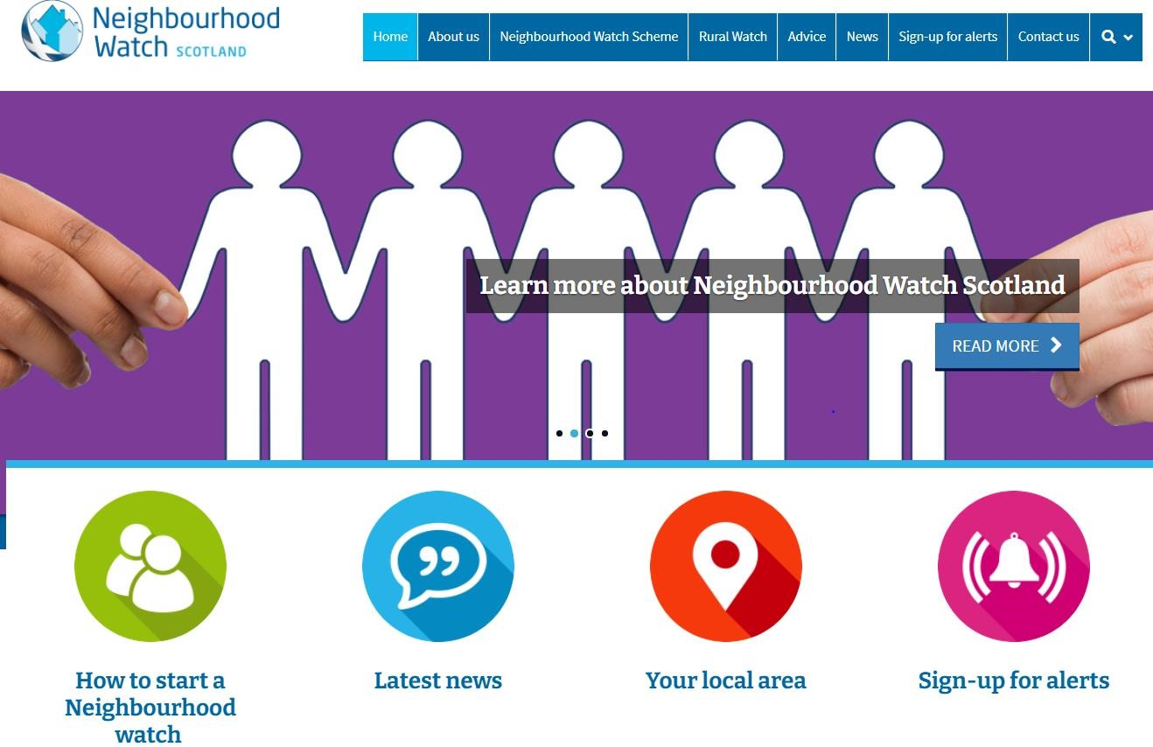

Pop your postcode into the “Your Local Area" search on our website. This will check for any existing groups near to where you live. If there is already a group covering your area, you can join it directly from our website, or contact the Coordinator if you have any queries.

If you don’t have access to the internet, you can give us a call and we will check the area for you. We can also send you paper copies of information and forms. You don’t have to be online to start or join a watch; our system can contact you by phone or text message.

Neighbourhood Watch Scotland SCIO, Charity Number SC036510

Registered Office: 21 Claylands Road Newbridge, Edinburgh, EH28 8LF

Phone Number : 01786 463732

Website : **www.neighbourhoodwatchscotland.co.uk**

# Starting a Group

If there’s no group in your area, and you want to start one, there are a few simple steps to follow. Our website has further advice and forms you can use:

* Find out if others in your area are interested in creating a Neighbourhood Watch
* - Identify a coordinator or main contact for the group
* - Go to **www.neighbourhoodwatchscotland.co.uk** and click ‘Join’ to register the group (or telephone us and we’ll do it for you.)
* - Ask the members of your scheme to register at the website and join the group
* - You may wish to arrange an initial meeting for the group where you can decide:
  + How the group will work.
  + If the group wants signs, and if so, how will these be funded.
  + How you will communicate. Meetings? E-mail? Leaflets? Social Media?
  + If you have particular safety issues you want to tackle?
  + If you need to work with local partners (e.g. police, local authority, fire service)

Sign up for alerts and information

If you’re not quite ready to join or start a Neighbourhood Watch, you can still sign up to receive safety information and alerts from us. Just click ‘Sign up for Alerts’ on our website and enter your details. Please encourage your family and friends to register too.

**The more people we can reach with our safety messages, the better!**

Neighbourhood Watch Scotland SCIO, Charity Number SC036510

Registered Office: 21 Claylands Road Newbridge, Edinburgh, EH28 8LF

Phone Number : 01786 463732

Website : **www.neighbourhoodwatchscotland.co.uk**