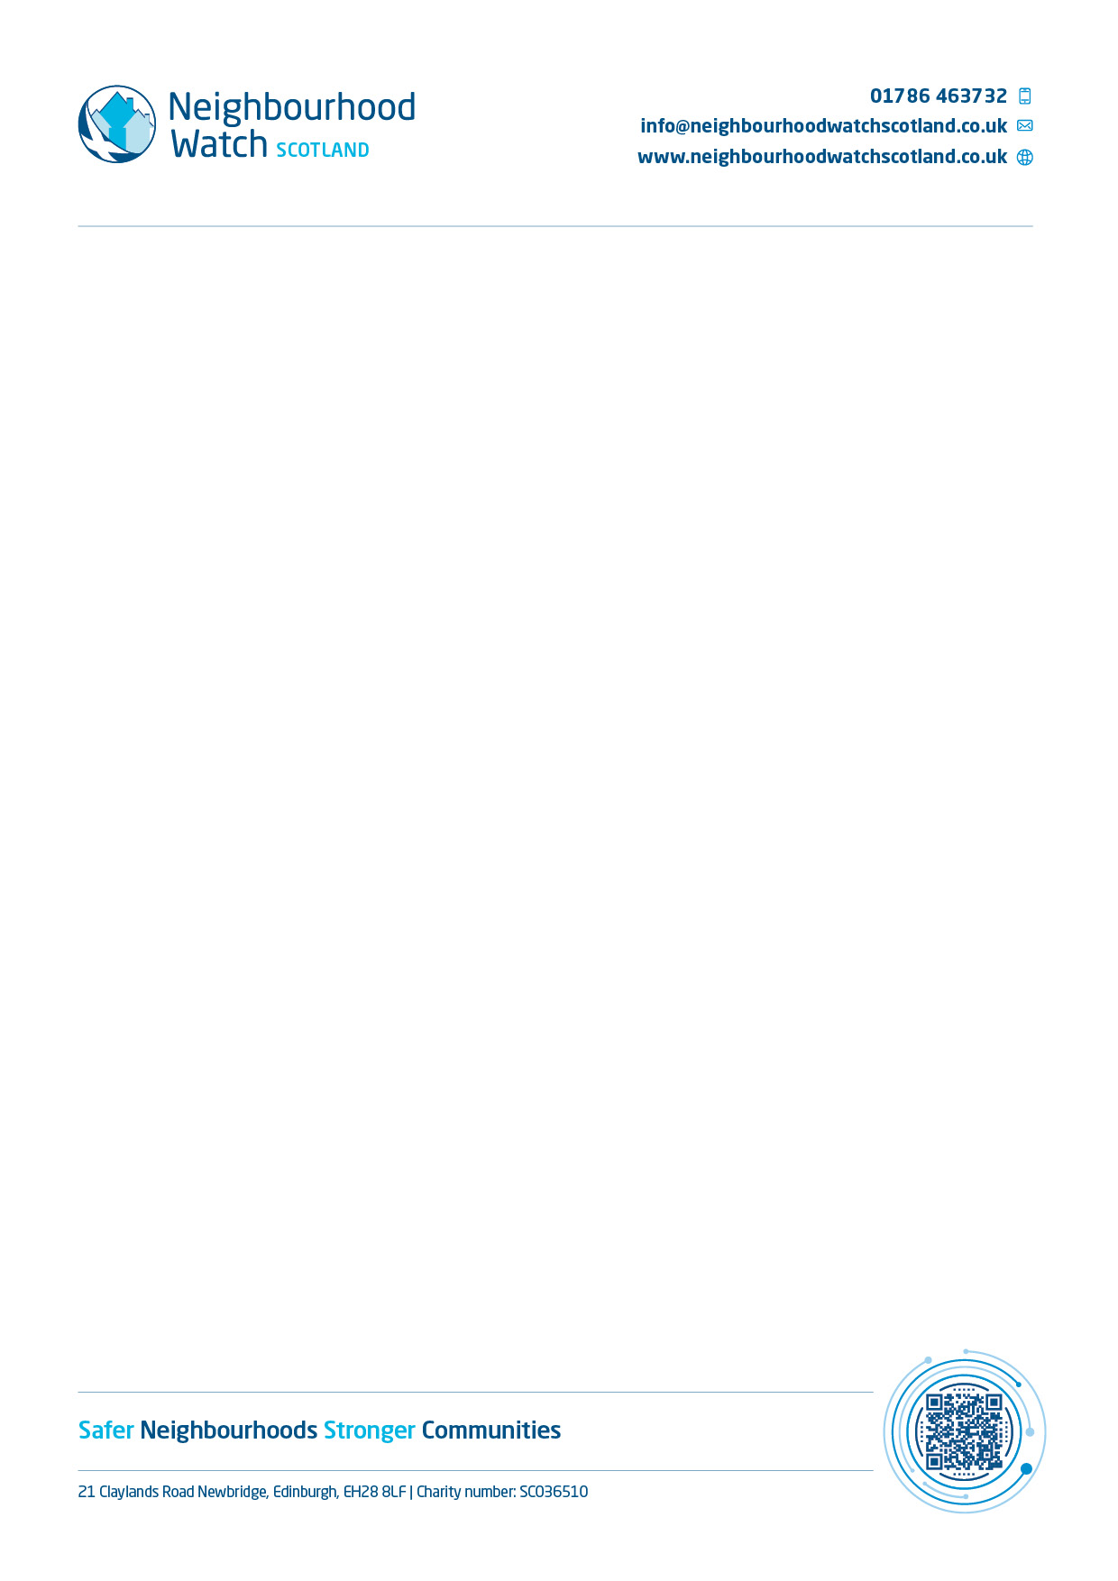

Interest form

Several of your neighbours have expressed an interest in forming a Neighbourhood Watch. Neighbourhood Watch is no longer all about reporting crime. It is about ensuring that communities are safe. This might include such diverse subjects as road safety, doorstep safety and internet safety.

Neighbourhood Watches develop and adapt to fit the communities they serve. They come in all shapes and sizes. Some watches are incorporated into existing groups, such as Community Safety Panels, Housing Associations or Tenants and Residents Associations, keeping safety on the agenda. Watches often work with other agencies like the police and local authorities to help make communities safer.

**What are the benefits of Neighbourhood Watch?**

• Areas of local concern can be addressed

• You can work together with your local community to determine and address priorities.

• You can work with other local NW Schemes, the police and other partners

• It is an opportunity to get to know your neighbours, local police officers and other service providers

I have provided my details as an initial point of contact. Please fill in the form below and return to my address, or contact me to arrange for me to collect it. The details you provide will be used for the purpose of determining whether or not a Neighbourhood Watch is viable, and thereafter to contact you regarding the decision.

|  |  |
| --- | --- |
| **Name:** |  |
| **Address:** |  |
| **Telephone:** |  |
| **E-mail:** |  |

----------------------------------------------------------------------------------------------------------------

* I am / am not**\*** interested in forming a Neighbourhood Watch.
* I am / am not**\*** prepared to assist in sharing/distributing information regarding community safety.

***(*Delete as applicable)***

|  |  |
| --- | --- |
| **Name:** |  |
| **Address:** |  |
| **Telephone:** |  |
| **E-mail:** |  |