NWS - Event Risk Assessment Template 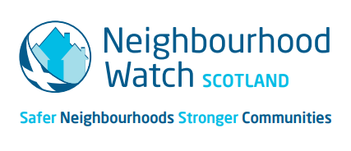

Event: |  | Date: |  | Location:

Activity  (Area of concern) | Hazards – what are they? | Persons at risk (employees, public, contractors ) | Control measures – what has been done to reduce risk? | Any further action required to reduce the risk (by whom and when) | Action status:  - New  - Ongoing  - Complete
Entrance / Exit
Car Parking
Building accessibility
Obstacles – cables on floor etc
Hospitality and catering
Slips, trips and falls
Manual handling
Equipment and machinery
Planned activities
First Aid provision
Spread of Covid
Safeguarding children
Lost children policy
Adverse weather
Crowd Management
Stewarding
Waste Management

Approved by: |  | Date: |  | Review date:

Notes:
- This template is a guidance tool for everyday use in respect of any low level events associated with NWS business. It has been created as an aid to help organisers prepare for a safe event (coffee morning, meeting, fundraiser event etc), and reduce the prospect of any risks of harm.
- This is not an exhaustive list and only to be used for guidance. You should add, or remove activities and the associated risks, which are appropriate for your event.
- This risk assessment tool originates from the general community response responsibilty to plan, prepare and recover from an adverse incident or emergency. It may be used to update any safety checklist or safety plan for the event (if appropriate).
- This risk assessment does not replace the role of the emergency services or other statutory organisations.

